UUM Student Satisfaction Analysis Monitoring Tool
Requirements Specification
Name | : Lim Yong Kang
Matric No | : 279868
Supervisor | : Dr Mohamad Sabri Bin Sinal@Zainal
Lecturer (Group) | : Ts. Dr Mohamed Ali b. Saip

1. INTRODUCTION
This section introduces the requirement specification document that specifies all system requirements that will govern the development and implementation of the UUM Student Satisfaction Analysis Monitoring Tool. It provides the purpose and scope of the system as
well as the definition of terms specific to the system.
1.1 Purpose
This "UUM Student Satisfaction Analysis Monitoring Tool" offers some contributions. The sentiment analysis process enables stakeholders to quickly collect, extract, analyze, and present actual data results, alleviating the resources and time required to gather information. Secondly, it helps stakeholders understand the analysis results and implement the necessary solutions to help students solve real-life problems. For example, suppose they want to know how students live in the dormitory. In this case, they can enter and search for posts about the student environment and then extract and analyse those posts to decide whether to improve or maintain the status. Thirdly, the stakeholders have the opportunity to understand and learn how to use sentiment analysis to improve their knowledge of managing the university. Finally, it also helps to change the perception of people (not only teachers, students, and staff) about the university in terms of
management.

1.2 Scope
The scope of this project are:

- "UUM Student Satisfaction Analysis Monitoring Tool" will be developed for the management authority of each department in UUM to analyze and visualize the collected data from social media.
- The data sources will be from a social media group, which is N.E.W.S.E.E.D., on Facebook.
- The post by students is chosen to focus on this project. Posts like announcements or advertisements will be eliminated.
- The posts written in languages other than English, such as Malay, Mandarin, and Tamil are removed.
- The positive and negative sentiments of the key or particular words about UUM
students' opinions will visualize on the monitoring tool.
1.3 Definitions, Acronyms and Abbreviations
UUMSSMAT- UUM Student Satisfaction Analysis Monitoring Tool
2. GENERAL DESCRIPTION
This section provides a high-level description of the UUM Student Satisfaction Analysis Monitoring Tool, identifies the users involved and their roles, and specifies the general constraints, assumptions and dependencies.
2.1 System Functions
UUM Student Satisfaction Analysis Monitoring Tool is a monitoring tool that allows the management authority of each department in UUM to analyse the sentiment of Facebook posts or comments, whether it is positive or negative or neutral. To confirm the accuracy of the sentiment in the sentences, the accuracy of determining sentiment groups such as positive, negative, and neutral will be displayed in the form of percentages. Therefore, the users can know the sentiment result of the post or comment. Moreover, the user can also view the details of the sentences.

2.2 User
The user who uses this system is the management authority of each department in UUM.
2.3 General Constraints
The system requires devices and an internet connection to access the system efficiently.
2.4 Assumptions and Dependencies
Assumption:
The user needs the basic skill of using the device.
3. REQUIREMENTS
This section lists all functional and non-functional requirements for the UUM Student Satisfaction Analysis Monitoring Tool, the use case(s) model, and a flowchart.
3.1 Functional Requirements
Table 1. The priority of the requirements is indicated by: M- Mandatory
D – Desirable.
O- Optional
Table 1: The Functional Requirements Definition
 | Num  . | Requirement ID | Requirements Description | Priorit  y
 | 1 | UUMSSMAT_01 | INPUT POST OR COMMENT
 |  | UUMSSMAT_01_  01 | The user must input the Facebook post or  comment into the monitoring tool. | M
 |  | UUMSSMAT_01_ 02 | The system will save the Facebook post or  comment. | M
 | 2. | UUMSSMAT_02 | ANALYSE TEXT SENTIMENT
 |  | UUMSSMAT_02_ 01 | The system should analyse text sentiment based on the input from Facebook posts or comments  whether it is positive, negative, or neutral. | M
 |  | UUMSSMAT_02_  02 | The system should save the analysed Facebook  post or comment. | M
 | 3. | UUMSSMAT_03 | VIEW ACCURACY

 |  | UUMSSMAT_03_ 01 | The system should display the accuracy of the  sentences by sentiment group (positive, negative, and neutral). | M
 | 4. | UUMSSMAT_04 | VIEW RESULT
 |  | UUMSSMAT_04_ 01 | The system should display the result of the sentences by sentiment group (positive or  negative or neutral). | M
 | 5. | UUMSSMAT_05 | VIEW DETAILS
 |  | UUMSSMAT_05_  01 | The system should display the details of the result. | M
3.2 Non-Functional Requirements
Table 2. The priority of the requirements is indicated by: M- Mandatory
D – Desirable. O- Optional

Table 2: The Non-functional requirements
 | Num  . | Requirement ID | Requirements Description | Priorit  y
 | 1 | UUMSSMAT_05 | SECURITY
 |  | UUMSSMAT_05_  01 | The system should protect the information of  Facebook posts and comments. | M
 | 2. | UUMSSMAT_06 | RELIABILITY ISSUES
 |  | UUMSSMAT_06_  01 | The system must allow users to use it without any  issues within 24 hours for single use. | M
 |  | UUMSSMAT_06_  02 | The system should crash no more than once. | M
 |  | UUMSSMAT_06_  03 | If the systems crash, it should behave perfectly  normally when reloaded again. | M
 | 3. | UUMSSMAT_07 | USABILITY ISSUES

 |  | UUMSSMAT_07_  01 | The system must provide a text box to allow the users to input the Facebook post and comments. | M
3.3 Use Case Model
A use case model for the system consists of user and UUM Student satisfaction Analysis Monitoring Tool use cases namely input post or comment, analyse text sentiment, view accuracy, view result , and view detail as illustrated in Figure 1.
Figure 1: The Use Case Diagram

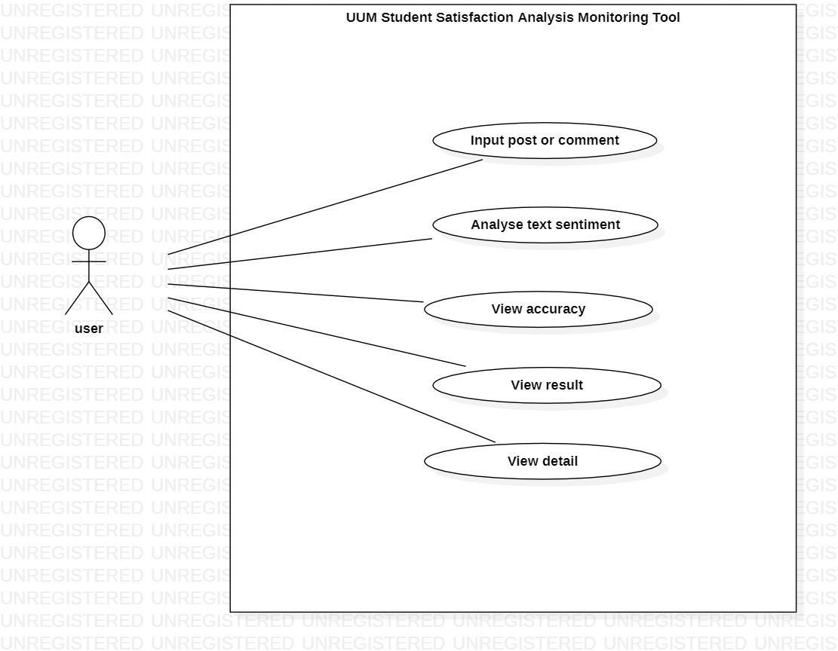

Table 3. Use case specifications

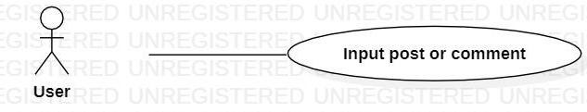

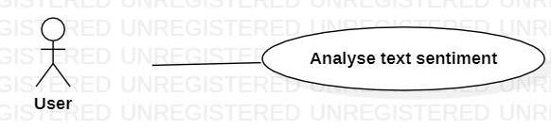

 | Brief Description | This use case enables the user to analyse the input Facebook post or comment, whether it is positive, negative, or neutral.
 | Pre- Conditions | - User must input the Facebook post or comment
 | Characteristic of Activation | Event-Driven (on user’s demand)
 | Flow of Events | Basic Flow (UUMSSAMT_02)
- The user must click the check button.
- The system must analyse the text data based on the input from Facebook posts or comments.
 | Post- Conditions | The system saves the information of analysed posts and comments.
 | Rule(s) | Not applicable
 | Constraint(s) | Only one post or comment can be analysed at the same time.
Brief Description | This use case enables the user to input the Facebook post or comment.
Pre- Conditions | Not applicable
Characteristic of Activation | Event-Driven (on user’s demand)
Flow of Events | Basic Flow (UUMSSAMT_01)
- The system must display the page
- The user should input the Facebook post and comment in the text bar.
Post- Conditions | The system saves the information of the post and comments.
Rule(s) | Not applicable
Constraint(s) | Only one post or comment can be input at the same time.

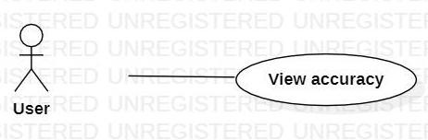

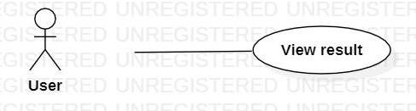
 | Brief Description | This use case enables the user to view the sentiment result of the post or comment.
 | Pre- Conditions | - User must input the Facebook post or comment  - User must click the check button.
 | Characteristic of Activation | Event-Driven (on client’s demand)
 | Flow of Events | Basic Flow (UUMSSAMT_04)
 |  | 1. The system must display the result of the sentences by sentiment group (positive or negative, or neutral)
 | Post- Conditions | The system saves the information of the sentiment result post and comment.
 | Rule(s) | Not applicable
 | Constraint(s) | Only one result is display at the same time
Brief Description | This use case enables the user to view the accuracy of the post or comment.
Pre- Conditions | - User must input the Facebook post or comment  - User must click the check button.
Characteristic of Activation | Event-Driven (on user’s demand)
Flow of Events | Basic Flow (UUMSSAMT_03)
1. The system must display the accuracy of the sentences by
sentiment group (positive, negative, and neutral)
Post- Conditions | The system saves the information on the sentiment accuracy of the post and comment.
Rule(s) | Not applicable
Constraint(s) | Not applicable

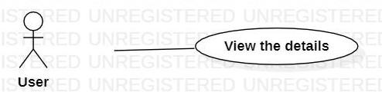
Brief Description | This use case will enable the user to view the details about the sentiment result of the post and comment.
Pre- Conditions | - User must input the Facebook post or comment  - User must click the check button.
Characteristic of Activation | Event-Driven (on client’s demand)
Flow of Events | Basic Flow (UUMSSAMT_05)
 | 1. The system must display the details of the sentences in different colour by referring to the sentiment result of the post or comment. (Red for negative)
Post- Conditions | Not applicable
Rule(s) | Not applicable
Constraint(s) | Only one detail of the sentence is display at the same time.

3.4 Flow Chart
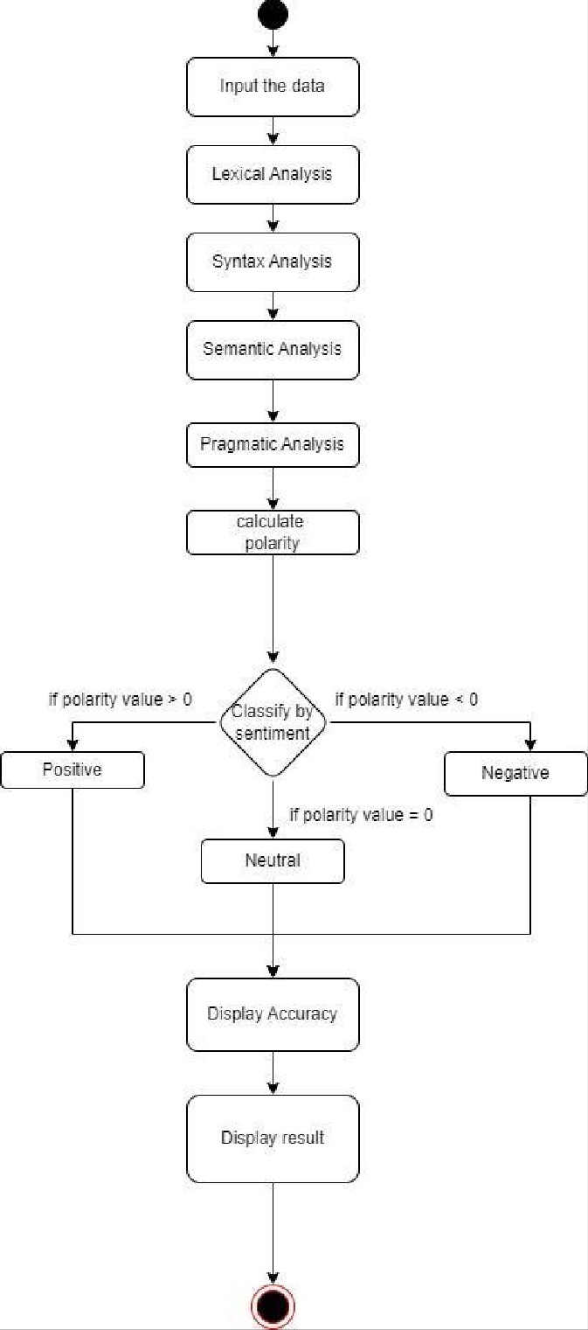

Student’s Signature: | Date :
TO BE FILLED BY THE SUPERVISOR
Remark:
Signature : | Date | :
Name :
Official Stamp:

